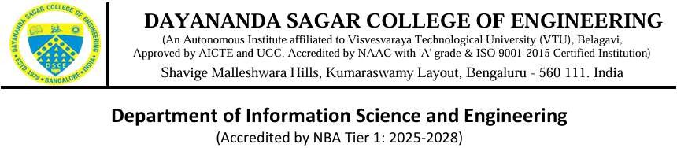

DSCE ACM Student Chapter
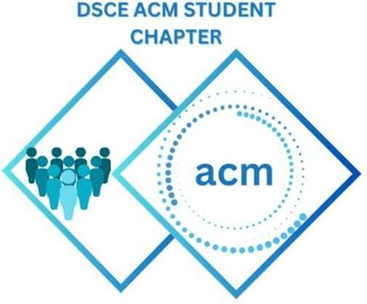

“AgriVision”

National Research Conclave on Agriculture

Introduction:
In an initiative to promote research, innovation, and interdisciplinary collaboration in the field of agriculture, AGRIVISION 2026 – National Research Conclave on Agriculture was organized with great enthusiasm by the DSCE ACM Student Chapter.
The event was conducted on 10th April 2026 at Dayananda Sagar College of Engineering (DSCE), Bengaluru, providing a dynamic platform for students, academicians, and industry professionals to explore the integration of modern technologies with agriculture.
The event focused on addressing real-world agricultural challenges through Artificial Intelligence, data analytics, and engineering interventions, thereby encouraging participants to think innovatively and contribute to sustainable development.

Inauguration and Dignitaries:
The event commenced at 9:30 AM at BB Block – Gallery Room No. 3, DSCE Bengaluru.
The ceremony was honored by the presence of distinguished Guests of Honour:
- Dr. B G Prasad, Principal, DSCE
- Dr. Annapurna P Patil, Dean Academics & HoD, ISE, DSCE
- Dr. Rajeshwari J, Convenor, Professor, ISE, DSCE
The inaugural session featured lighting of the ceremonial lamp, addresses by the dignitaries, and a detailed briefing on the hackathon format and evaluation process.

Inauguration Photos:
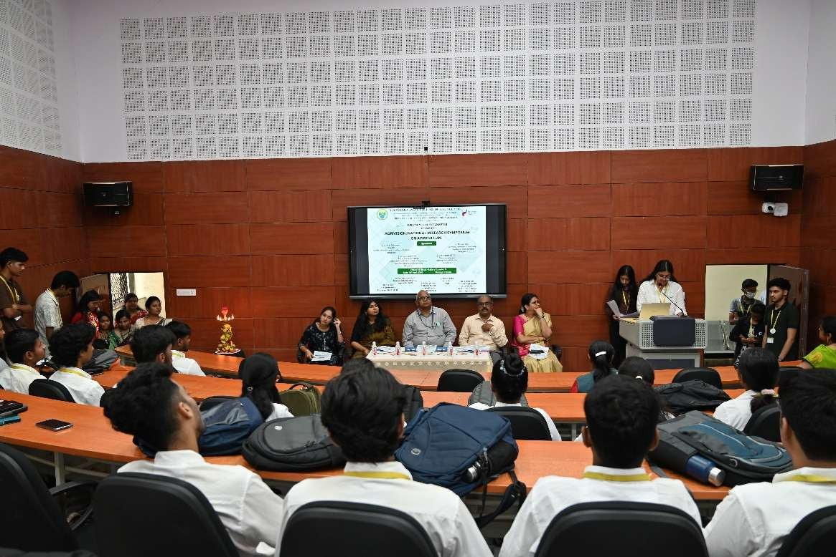

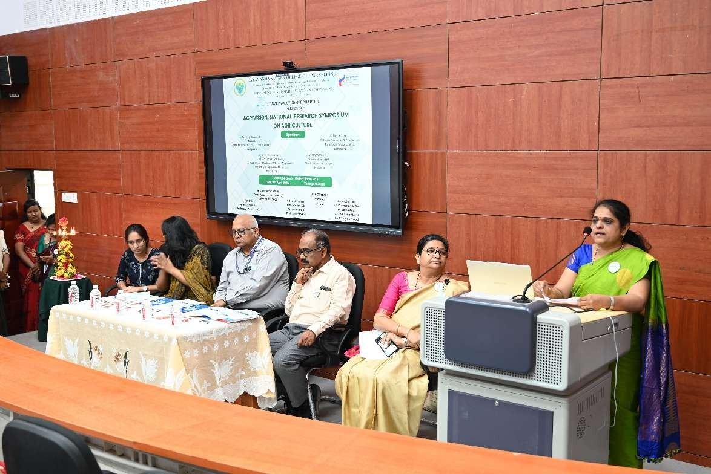

Technical Sessions and Speakers
The event featured a series of expert talks by eminent speakers from academia and industry, each bringing valuable insights into different dimensions of agriculture and technology.

Dr. T. S. Channesh
Director, Centre for Public Understanding of Science, Bengaluru
Dr. Channesh delivered an insightful session on “Engineering Interventions in Farming”, highlighting the importance of technology-driven solutions in agriculture.
He discussed:
- The need for indigenous technological development
- Challenges like urbanization, soil degradation, and resource limitations
- Importance of logistics, storage, and smart farming systems
His talk emphasized how engineering solutions can make farming efficient, less labor-intensive, and sustainable.

Dr. G. C. Jayashree
Associate Professor & Head, UAS Bengaluru
Dr. Jayashree presented on “Artificial Intelligence in Agriculture”, focusing on the transformative impact of AI in modern farming.
Key highlights included:
- Precision farming techniques
- Smart irrigation systems
- Crop monitoring and disease detection
- Yield prediction using data analytics
She emphasized how AI enables data-driven decision-making, improving productivity while reducing resource wastage.

Dhanyashree S. G
Senior Agronomist, Farmitopia Pvt. Ltd.
Dhanyashree S. G shared practical insights into field-level agricultural challenges and solutions.
Her session focused on:
- Sustainable farming practices
- Modern agronomy techniques
- Bridging the gap between technology and real-world farming

Nayana Das
Software Developer & Data Analyst, Farmitopia Pvt. Ltd.
Nayana Das highlighted the role of technology and data analytics in agriculture, discussing:
- Integration of digital platforms in farming ecosystems
- Importance of data-driven agriculture
- Building a connected food system
Her talk provided an industry perspective on how technology is reshaping agriculture.

Participation Overview
The event witnessed active participation from students of various departments, showcasing strong interest in agriculture, AI, and emerging technologies.
Participants engaged enthusiastically in:
- Technical sessions
- Knowledge discussions
- Interactive Q&A sessions with speakers
The event fostered a collaborative learning environment and encouraged students to explore innovative agricultural solutions.

Poster Presentation Competition
Subsequent to the event, another major highlight of the event was the Poster Presentation Competition, which provided a platform for students to present innovative ideas and research work.
Participants showcased projects that blended Artificial Intelligence, modern technologies, and agriculture to solve real-world problems.
The themes included:
- Smart irrigation systems
- Crop disease detection using AI
- Sustainable farming solutions
- Agricultural automation and robotics
The competition encouraged creativity, research thinking, and practical problem-solving skills among students.

Winners of Poster Presentation
The competition concluded with the recognition of outstanding projects:
- First Place: D Ramkishan Karanth, Garv Kumar Agarwal, Suhas K
- Second Place: Parinita C S, Mrudhula V, Lohitha A
- Third Place: Darshan K, Sameeksha M S, Srujal K B
The winning teams demonstrated innovation, technical excellence, and real-world applicability in their solutions.

Event Organization
The successful execution of AGRIVISION 2026 was made possible through the dedicated efforts of faculty members and organizers:

Convenor:
Dr. Rajeshwari J

Co-Conveners:
- Prof. Shalini K B
- Dr. Madhura J
- Prof. Bharath B C

Co-ordinators:
- Dr. Chandrakala BM
- Dr. Latha Anuj
- Dr. Prathima Mabel
- Prof. Vidya Byakad
The organizing team ensured smooth coordination and seamless execution of all activities.

Evaluation Photos:
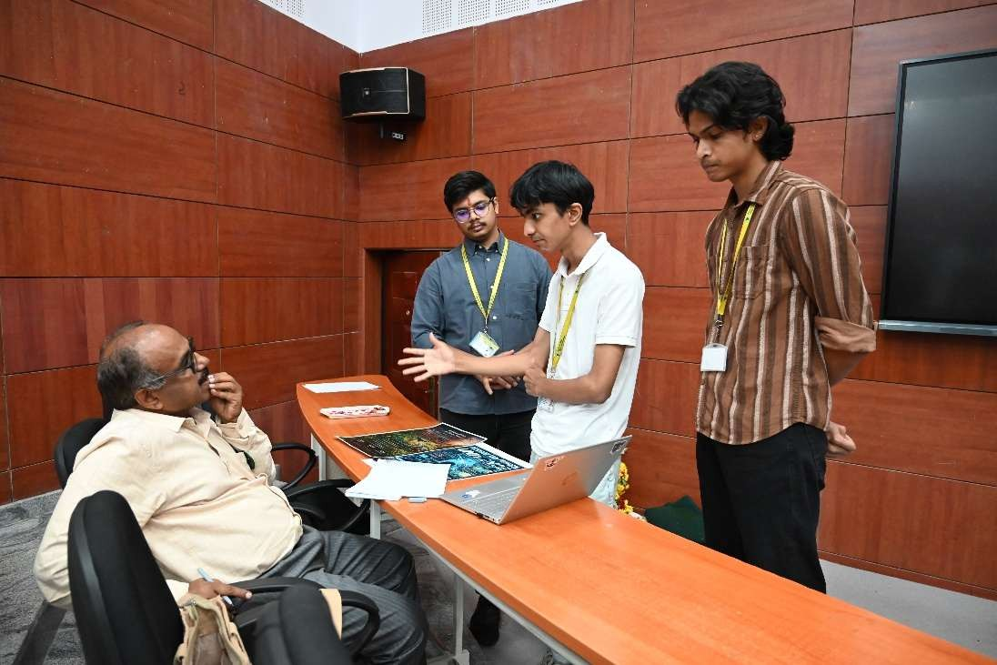

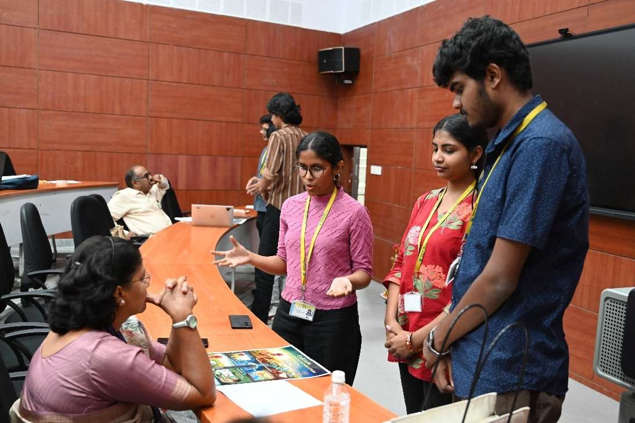

Support and Collaboration:
The success of AGRIVISION 2026 was the result of coordinated efforts and strong support from all stakeholders.
- Heartfelt thanks to the Management of DSCE for their constant encouragement and support in organizing the event.
- Special gratitude to Dr. Annapurna P Patil, Dean Academics & HoD, Department of ISE, DSCE, whose guidance and motivation played a crucial role in the successful execution of the event.
- Sincere appreciation to Dr. Madhura J, Prof. Shalini K B, and Prof. Bharath B C for their meticulous planning, coordination, and management of the event.
- Acknowledgment to the faculty members, student volunteers, and DSCE ACM Student Chapter members, whose dedication ensured the smooth flow of all activities.
The collective effort and teamwork demonstrated throughout the event highlight the strength of academic collaboration and student-driven initiatives.
The collaboration between DSCE and DSATM teams highlighted the power of joint academic initiatives.

Feedback from Participants:
Participants described AGRIVISION 2026 as “an insightful and enriching experience” and “a platform that bridged the gap between technology and agriculture.”
Many appreciated:
- The expert talks by distinguished speakers, which provided both academic and industry perspectives
- The opportunity to gain knowledge about AI, smart farming, and modern agricultural practices
- The interactive sessions, which encouraged discussions and idea exchange Participants of the Poster Presentation Competition expressed that the event:
- Enhanced their research and presentation skills
- Encouraged them to think about real-world agricultural challenges
- Motivated them to explore innovative, technology-driven solutions
Overall, the event was well-received for its structured organization, relevant themes, and engaging content, leaving participants inspired to further explore the field of agriculture and technology.

Outcomes and Benefits:
AGRIVISION 2026 contributed significantly to:
- Skill Development – Enhancing knowledge in AI and agriculture
- Innovation Promotion – Encouraging creative solutions
- Real-World Problem Solving – Addressing agricultural challenges
- Interdisciplinary Learning – Bridging technology and farming
- Sustainable Development Awareness – Promoting eco-friendly practices
The event inspired participants to think critically and apply technology for societal impact.

Conclusion:
AGRIVISION 2026 was a resounding success, serving as a platform for knowledge exchange, innovation, and collaboration.
The event not only deepened participants’ understanding of modern agricultural technologies but also motivated them to contribute towards sustainable and technology-driven farming solutions.
The event stands as a proud achievement of the DSCE ACM Student Chapter, setting a benchmark for future academic and technical initiatives.

Event Photo
